Fetch logic is responsible for generating the address to the BRAMs to get tiles and pass it to the SA,
Treating it as a black box here is a table for its interface:
Direction | signal | Description
input | Clk | system clock
input | Reset | System asynchronous active low reset
input | Start_fetch | takes a start pulse and begins fetching from the BRAM we choose
input | Reset_addr_counter | reset_counter input to reset the address pointer
input | Buffer_Select | buffer select input to select which buffer we will fetch from (W, B, I, Q, K, V)
input | Tiles_Control | tiles_control input to choose whether we will fetch 32 (W, B) rows per tile or 512 rows per tile (I, Q, K, V)
output | Bram_addr | It outputs the address we will read from to the chosen BRAM
output | Bram_en | Outputs enable to BRAM (vivado restriction)
output | Fetch_done | Outputs fetch_done signal (pulse) to SA indicating the tile is done
output | busy | Outputs busy signal indicating we are fetching

For weights buffer:
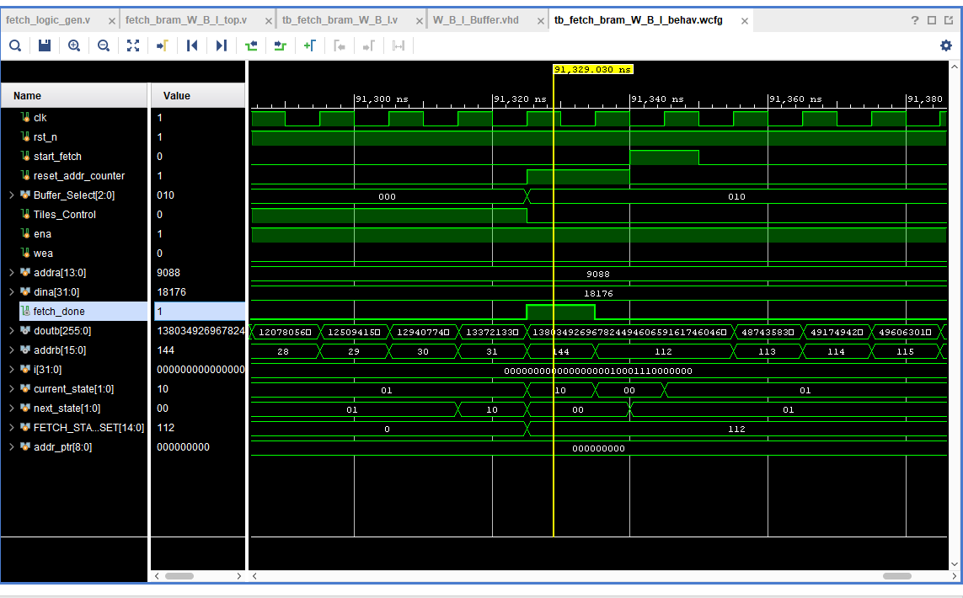
- Here we see that the valid pulse arises one cycle after finishing and we need another cycle to assert the start signal for the next tile (input tile)
- Notice how the address for a weight tile ends at address 31 as we are only using 32 rows tile fetch
- Notice how the starting address for the input tile (I) begins at 112
For inputs buffer:
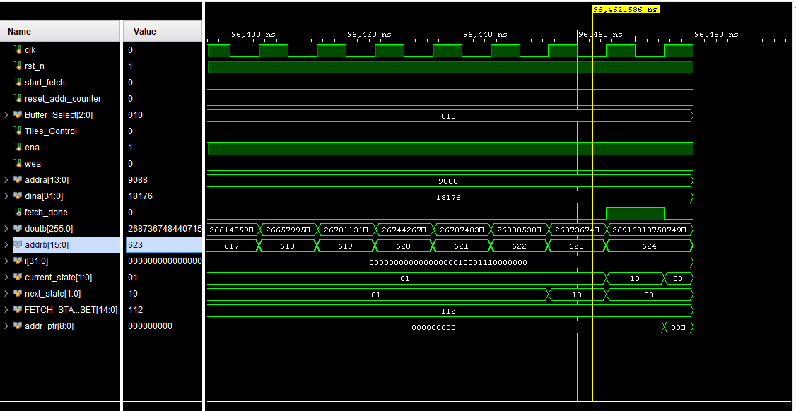
- For input tile (512) notice how we ended our fetching at address 623 as (512 +112) = 624 but we include the zero address, but what is 112? We will have a detailed diagram for the buffers with their values, but for now this is the starting address for the Input buffer

For K buffer:
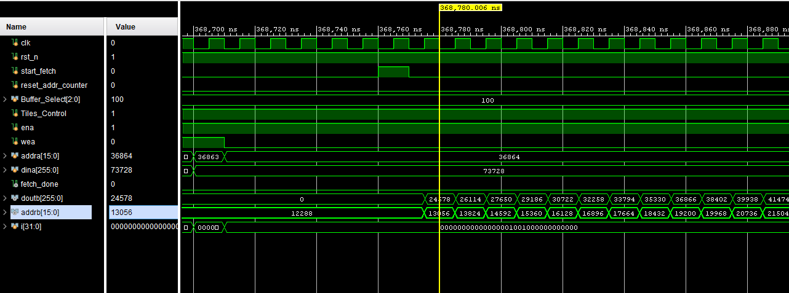
- In multi head attention equation we need the K buffer specifically to get fetched in a transposition manner
- Notice that the first address is 12288 then the next address is 13056 why? As if we do 12288 – 13056 = 768, and this way we get the elements transposed from K buffer considering our K buffer is 512 x 768 matrix
- So we are incrementing the address by 768 to take the elements in the first column then moving to the second and so on
- If we calculate the no. of the elements we will take from the first column it will be: 12288 (buffer size) / 768 = 16 so we will need to pass the first 2 columns elements
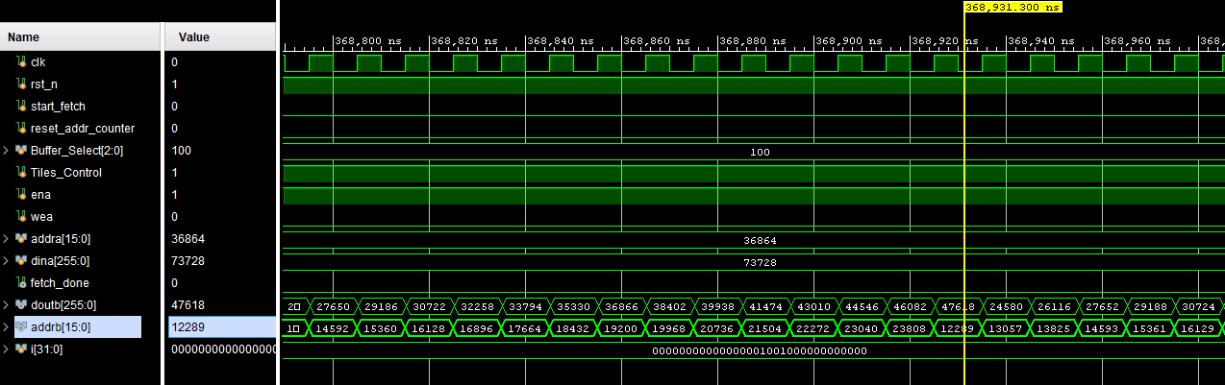
- Here is the point we’re talking about, when we reached the 23808 address if we increment for another 768 we will end up in 24576 and that’s the first address of the V buffer so we are no longer in our K buffer anymore
- So when we reach the 23808 we go up again to the first element for the second column which is at the address 12289 and we increment 768 all along to reach to the bottom of this column and here are the 32 stationary elements for our Systolic array
For Q buffer:
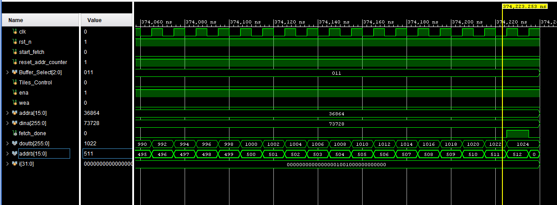
- We’ve started at address 0 and we took a 512 element tile like normal

For V matrix:
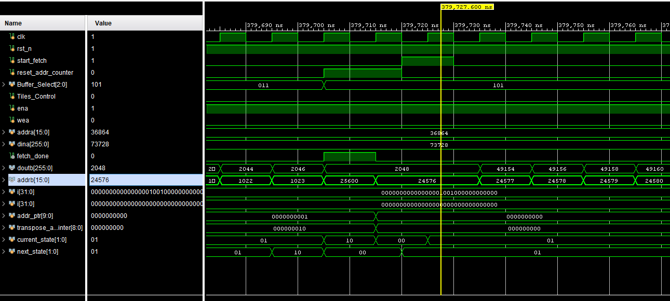
- We begin at 24576 address and we tile a normal 512 element tile

W B I Buffer:
